# **GIT COMMANDS**

1. Open the git bash
2. For checking the git version

git – -version

1. Setting the user name and email id

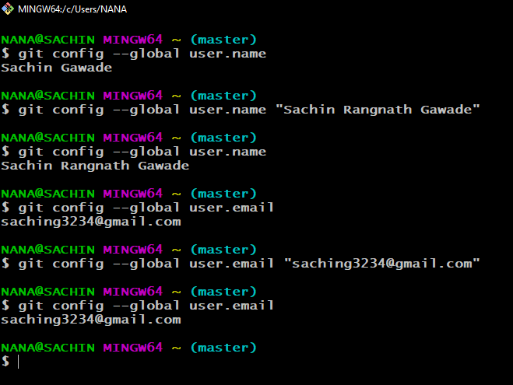

1. Editing the details using the edit command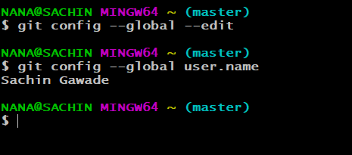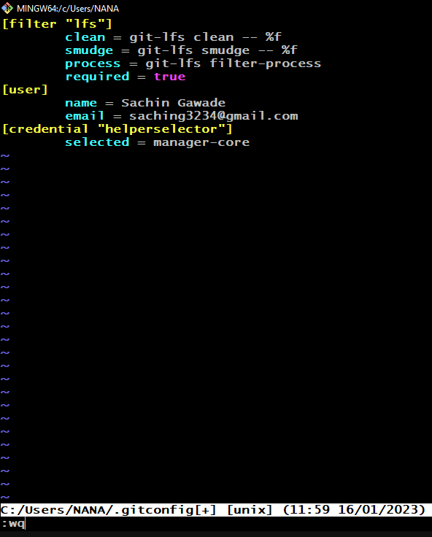
2. Making repository and initializing it

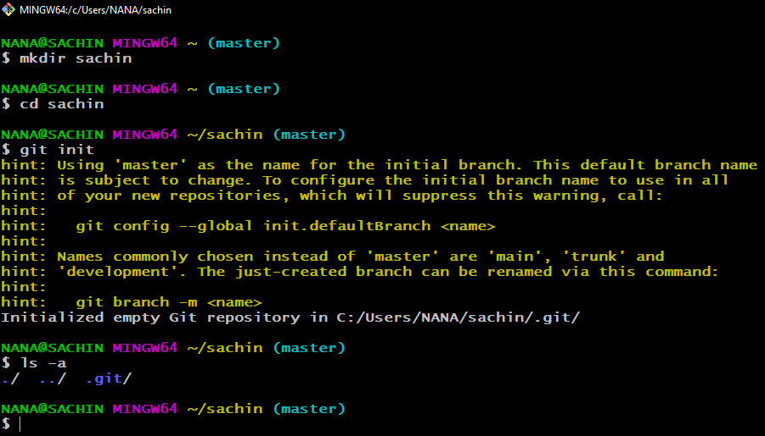

1. After creating the Sum.java file
2. Git status

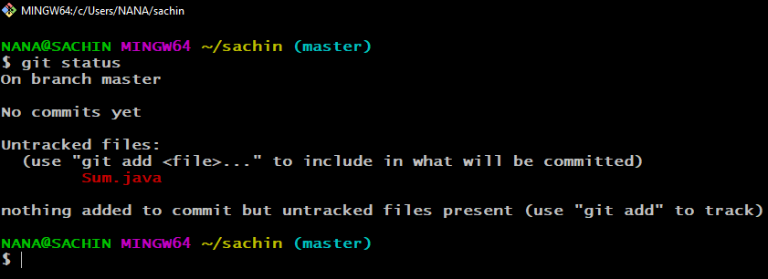

1. Adding the Sum.java file in the staging area

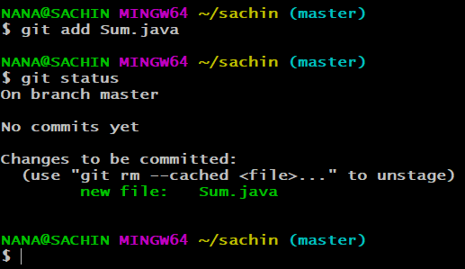

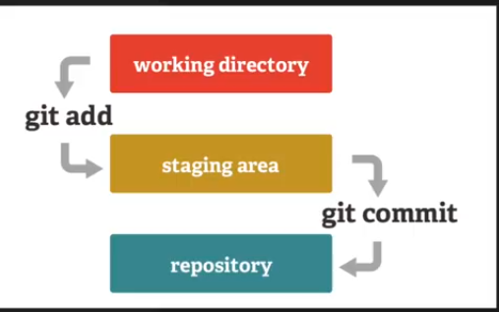

1. Committing the staging area file by git commit –m “commit msg”

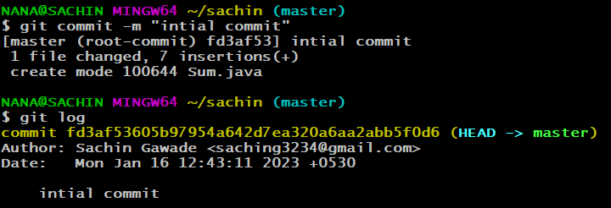

1. git add . :-this command is used to add all unstaged files in the staging area
2. git log :- this command is used see the log details or previous activity details.

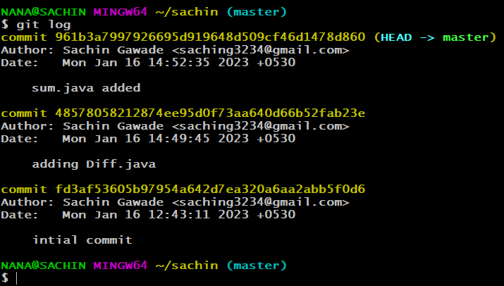

1. git checkout hash code is used to jump to that commit state

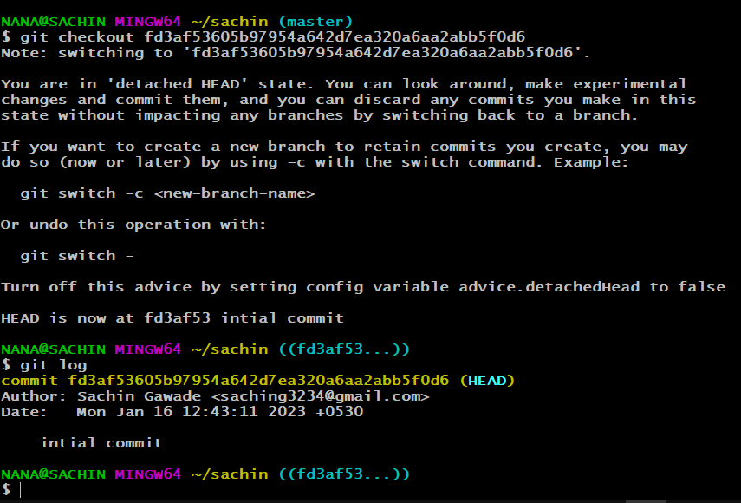

1. git checkout master :- it is used to go back to previous state

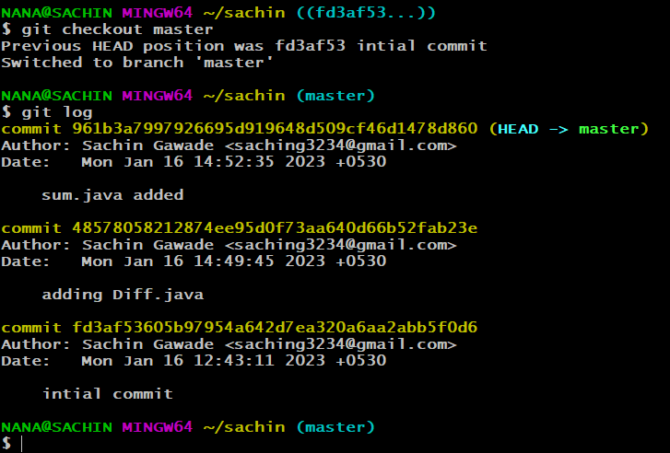

1. git branch dev :- it used to make a new dev branch

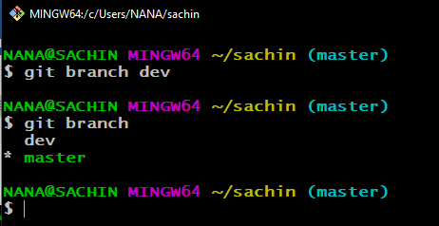

1. get checkout dev :- this command is used to switch to a dev branch

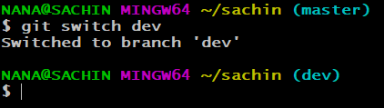

1. git checkout -b sachin/multiply :- it is used to create a new branch to to switch to that branch

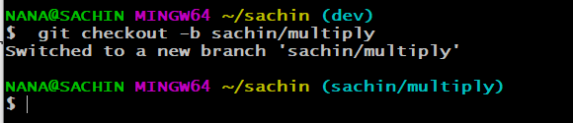

1. merge command is used to merge other branch existing branch

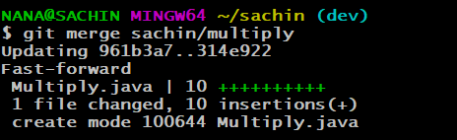

1. git ignore file not track the mentioned files

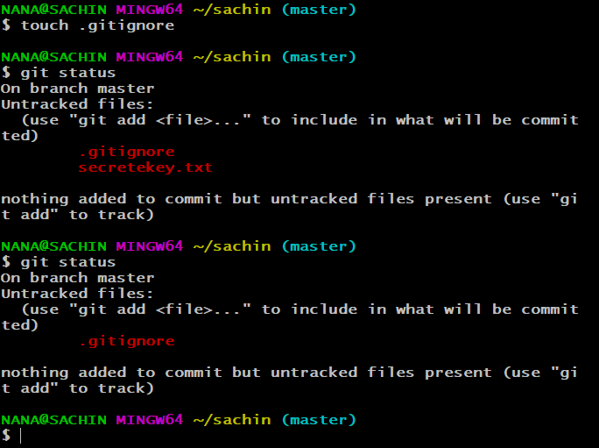

1. pushing the code to the github repo

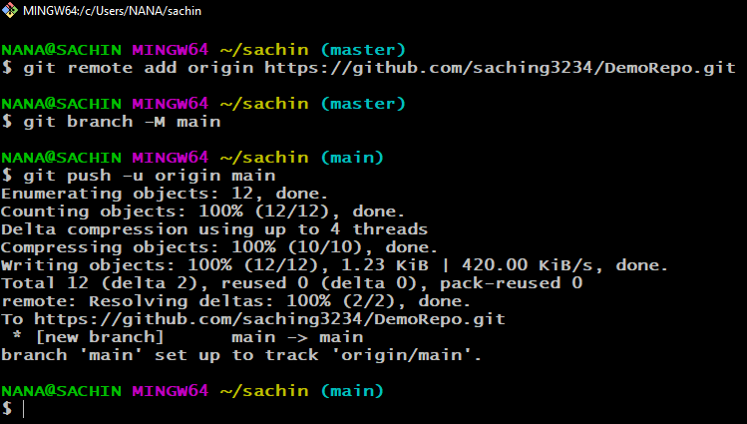

1. saving the changed file and pushing the same to github repo

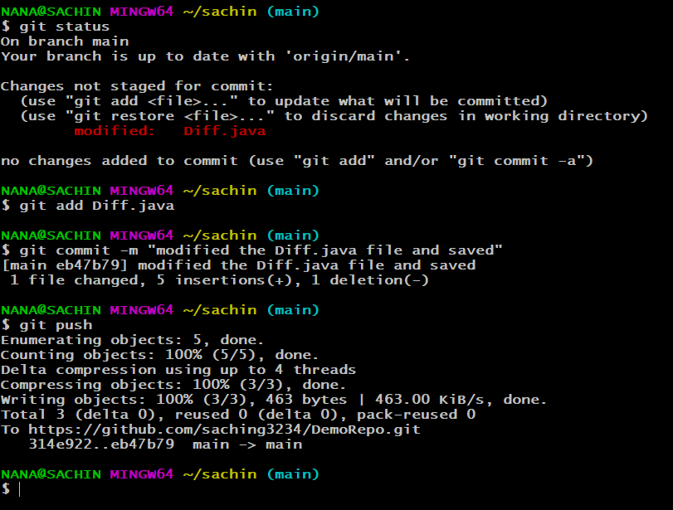

1. pushing the dev branch to github

